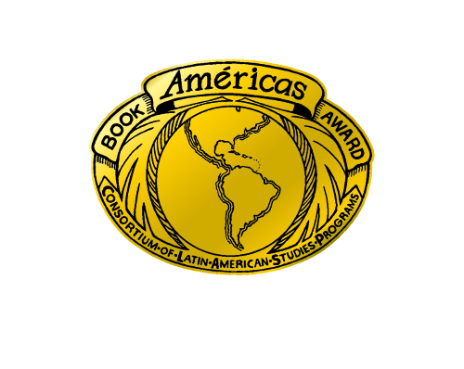
2027 Américas Award
For Children’s & Young Adult Literature
Call for Submissions

RATIONALE
To encourage and commend authors, illustrators and publishers who produce quality children’s and young adult books that portray Latin America, the Caribbean, or Latinx communities in the United States, and to provide teachers with recommendations for classroom use, the national Consortium of Latin American Studies Programs (CLASP) offers up to two annual book awards, together with a commended list of titles.

CRITERIA
Two awards are given each year, one for a picture book and one for a young adult or middle grade book. The awards recognize U.S. published (including Puerto Rico) works of fiction, poetry, folklore, non-fiction, and works in translation that authentically and engagingly portray Latin America, the Caribbean, or the Latinx community in the United States. By linking the Américas, the intent is to reach beyond geographic borders, as well as multicultural-international boundaries, focusing instead upon cultural heritages within the hemisphere. Books will be judged for:

1. Distinctive literary quality
1.a. Is the story unique or innovative in its development of characters, setting, plot and other narrative elements?
1.b. Is the story engaging for its intended audience?

2. Cultural contextualization
2.a. Does the book accurately and sensitively represent a cultural setting, practice, identity, or way of life? Accurately here is defined as with integrity and appropriate nuance, not pure fidelity since there is no one single Latin American or Latinx experience.
2.b. Does the book convey sufficient cultural detail that the reader will gain greater understanding about Latin American, Caribbean or Latinx cultures, histories, and identities?

3. Exceptional aesthetic appeal, where applicable.

4. The Américas Award recognizes the book (as opposed to the individual author or illustrator).
4.a. Is the book appealing as a whole?

5. Potential for classroom use
5.a. Does the book lend itself to use in multiple subject areas at the primary or secondary level?
5.b. Would the book make a strong addition to a classroom or school library?

ELIGIBILITY
- The book must be published in 2026.
- The title may be for primary or secondary reading levels.
- Language of publication may be English, Spanish, Portuguese, French, or any language indigenous to the Americas.
- The book must be published in the United States (including Puerto Rico) or by a publisher with offices within the U.S.
- Submissions may be fiction, poetry, folklore, or non-fiction.
- A book will only be considered in its first year of publication in the United States. A book originally published in the U.S. in English with a translated edition in a subsequent year will only be eligible the first year of the edition.

PROCESS
To nominate a 2026 copyright title, publishers are invited to submit review copies to the committee members listed below by January 31, 2027. There is no entry fee.

The list of award winners, honor books, and commended titles will be announced in June 2027, recognizing works published in 2026.

2027 Américas Award
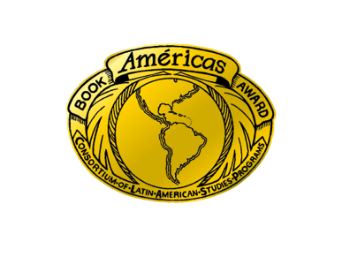
for Children’s and Young Adult Literature

Please send nine (9) copies of the nominated book (one to each person) to the Review Committee Members and the Award Coordinators listed below:

REVIEW COMMITTEE MEMBERS

Julia Byrd *
3052 Blossom Street
Oakland, CA 94601
juliabyrd@berkeley.edu
2025-2027

Laura Gonzalez
1308 67th Street
Berkeley CA 94702
laura.gonzalez@ousd.org
2027-2029

Jessi Nicholls
3410 Robert Street
New Orleans, LA 70125
Jnicholla@gmail.com
2026-2028

Dr. Marisela Ramos
1807 17th St., Unit 4
Santa Monica, CA 90404
marisela.j.ramos@gmail.com
2026-2028

Vivian Santana Pacheco *
3052 Blossom Street
Oakland, CA 94601
vivsantana12@gmail.com
2026-2028

Flavia M. Vidal, Ph.D.
70 Steuben Court
West Lafayette, IN 47906
fmvidal@purdue.edu
2026-2028

Kristine Witko
8967 Omega Ct
Springfield, VA 22152
kristinewitko@gmail.com
2026-2028

AWARD COORDINATORS

Cynthia Garza
Tulane University
Stone Center for Latin American Studies
6801 Freret Street
100 Jones Hall
New Orleans, LA 70118
cgarza@tulane.edu

Ex-officio
Monica VanBladel
Center for Latin American & Caribbean Studies
University of Wisconsin – Milwaukee
2025 E. Newport Avenue, NWQ B 2479
Milwaukee, WI 53211

* Publishers may send both Julia Byrd's and Vivian Santana Pacheco's copies in combined packaging to 3052 Blossom Street, Oakland, CA 94601.

